IBM Cloud Registration

Team Lead : Timple Roshni Augustina

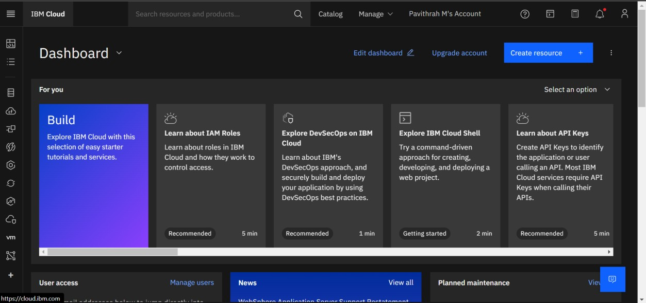

Team Member 1: Kamali

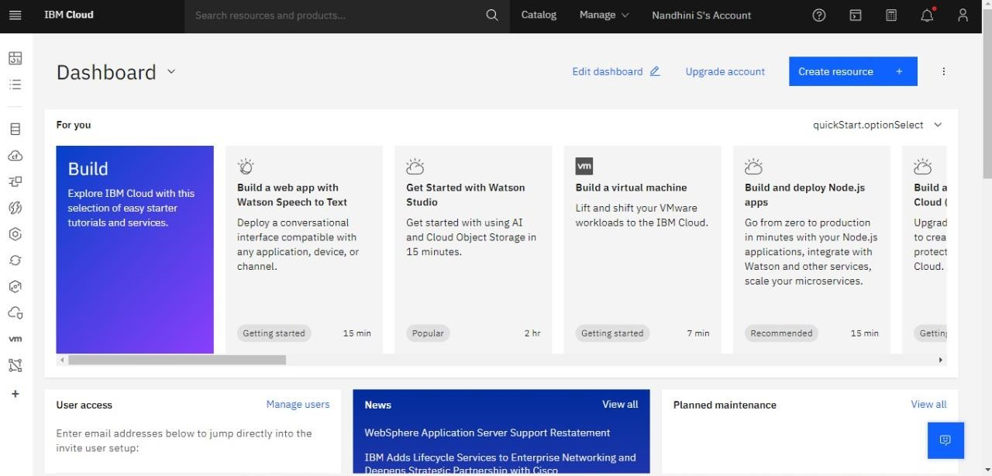

Team Member 2 : Lavanya

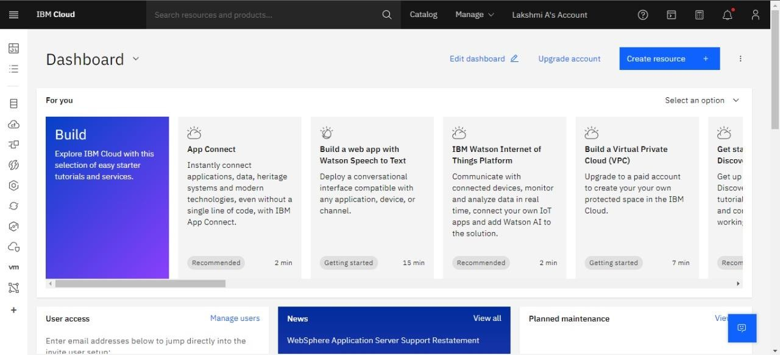

Team Member 4 : Partheeban

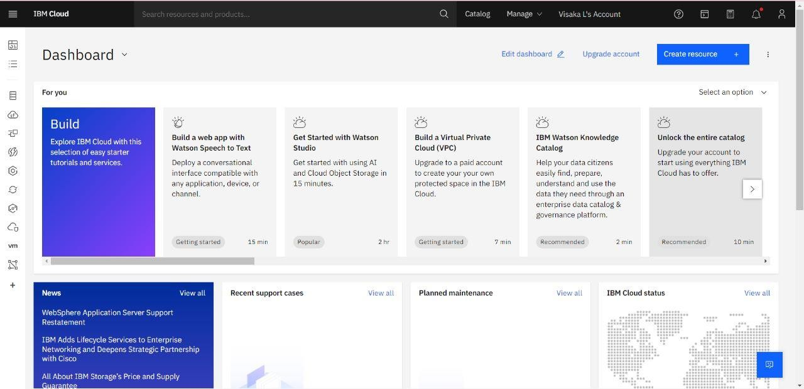

Team Member 5 : Dhayathipathy

